Acquisitions and Mergers of Google incorporation

Name of Student
Institution

Contents
PART A: 2
Introduction 2
Strengths, weaknesses, opportunities, and threats of Intel corporation 2
Merging Intel corporation through horizontal acquisition 5
The synergy of Intel corporation with its mergers and acquisitions 6
Valuation of NVIDIA Corporation 7
Part B: 14
Importance of effective teamwork and coordination of activities in future studies and 14
professional practice. 14
References 16

PART A:

Introduction
Challenged with the current trends in the design and manufacturing of essential technologies, we were tasked by Credit Suisse (CS) to assess the possible mergers and acquisitions to help Intel corporation to make accurate projections for the future. Also, this was to assist Intel corporation management in making important decisions in terms of identifying the most viable investment platforms. As a team, we evaluated extensively the strategies and objectives used by the Intel corporation to monopolize the technology space globally.

Strengths, weaknesses, opportunities, and threats of Intel corporation
Intel corporation has many strengths such as partnership with Microsoft incorporation, use of high-speed fabrication processes, a technology leader, having a brand value and a brand recognition, commitment to research and development, market share and presence, field-programmable gate array technology, artificial intelligence, license to start building ARM-based chips and Big Data Analytics Platform .
Firstly, Intel corporation thrives largely from its partnership with Microsoft corporation that has monopolized the market for desktop operating systems(Furgerson,2017). This partnership has been a great asset for Intel corporation as they do not have to go out there to look for customers since their partner, Microsoft corporation already has a strong market presence. Secondly, Intel gains from the proceeds it gets from its fast and efficient processors made for the window-based operating system that is currently dominating the operating system market. Microsoft incorporation also greatly benefits from the efficient processors manufactured by Intel corporation enabling the windows machines to operate effectively. Another strength of Intel corporation is the high-speed fabrication processes that make it be ahead of its competitors. Also, according to Bhasin (2019), Intel Corporation is a technology leader Sin laptops desktop, gaming and assembling features.
The business has managed to be one of the top technology companies in the world through the influence of its powerful processor technologies. Besides, Intel has maintained a brand value as it was ranked 40th according to the Brand Finance survey was done in 2016 (Bhasin, 2019). Also, Intel has been able to maintain brand recognition and ranks no 14th according to a recent survey by Interbrand(Felton,2017). It also falls in the category of the most admired companies in the world and ranks 45th according to a survey done by Fortune company(Ascimecca,2018). Also, Intel is committed to research and development that enables them to improve their technologies dynamically and be ahead of other companies in the processor design and manufacturing industry. Besides, Intel corporation has a very large market share and market presence world over. It is classified as one of the biggest microchip manufacturers globally (Bhasin, 2019). Also, Intel corporation has the advantage of having field-programmable gate array technology that helps them improve the functionalities of their servers as well as their data centers. They also have an unparalleled artificial intelligence technology to putting them ahead of their competitors. Also, they have a license to start building ARM-based chips that are even used by apple to manufacture gadgets such as iPhone 7 that is one of their greatest advantage in the technology market. Again, Intel corporation thrives on the Big Data Platform whereby they collect information on the trends in the microchips market to help them produce better products(K&D,2017).
However, some of the glaring weaknesses of Intel corporation are overproduction, lack of diversity and diminishing profits. Firstly, there is the overproduction of microchips in the microprocessor industry with other popular brands such as Samsung and Taiwan Semiconductor Manufacturing Company (TSMC) also flooding the market with their microchips hence flooding the market. This has made Intel corporation not to be able to make profits as it used to. Besides, K&D (2017) observes that Intel lacks diversity as it has majorly concentrated on the production of microchips for personal computers depriving them of other upcoming markets such as mobile phones and watches. This must be so because of a market dominated by the window-based market by Microsoft corporation. Besides, Intel corporations’ profits have been dwindling year after year. For instance, Intel's annual net income realized in 2016 was $10.316 billion that marked a 9.67% drop from 2015. Consequently, in the year 2017, Intel corporation got $9.601 billion that indicated a 6.93% reduction from 2016. It is only in the year 2018 that Intel Corporation realized an increase in profits from 2017. There was an increase in profits of 119.28% in 2017. Gradually, Intel corporation has continued registering reduction profit margins. Notable is the drop in the Intel net income for the quarter ending June 30, 2019, estimated at $4.179 billion marking a 16.52% decline in its profit margins (Intel Net Income 2006-2019: INTC, n.d).
Intel corporation has several opportunities that can propel it to profitability if maximumly utilized by its top management. For instance, Intel corporation can capitalize on the ever-expanding smartphone market, drones, automatic cars and the digital revolution that is trending globally. Firstly, the smartphone market is expanding every day and if Intel can manufacture microchips to meet the needs of this market, it can make a lot of profits. Secondly, Intel can also focus on the manufacture of low cost and less energy-consuming microchips for drones. Drones are the future solutions to access to high-risk areas such as war-torn areas, explorations in space and even security surveillance. Investing in such a fast-growing area in the technology field is a sure way of steering Intel to profitability. Also, the production of automatic cars is another viable opportunity Intel Corporation can invest in. These cars rely heavily on the use of microchips to automate their operations. Investing in automatic cars can make Intel Corporation experience an upsurge in profit margins. Besides, Intel can target the growing computer market and ensure that they have the largest share to enable generate more revenue.
Unfortunately, Intel corporation faces several threats that seem to seriously affect the prospects of design and manufacture of processors. Firstly, Intel depends on only one product that can prove to be detrimental in case another company invents better microchips than theirs. Also, Intel faces great competition from companies such as AMD who produce equally powerful processors and have the potential of overturning Intel’s market presence. Again, China is proving to be one country that has the capability of producing virtually anything. Even the efficiency of Chinese products is questionable, they present a serious threat to Intel’s microchip’s market. Besides, Intel Corporation constantly faces challenges caused by price wars with other companies such as AMD who are doing their best to produce efficient microchips at affordable prices. Again, due to the ever-changing technology, preference is being given to hands-free devices. Intel corporation should invest in this area to benefit in the future.

Merging Intel corporation through horizontal acquisition
Intel Corporation can be merged with big semi-conductor processor companies such as NVIDIA, AMD, and Qualcomm since their products are similar. Such a merger will be a great advantage to Intel corporation in the reduction of competition and capturing a bigger market share. For instance, since NVIDIA top-line sales a majorly from its graphic microprocessors designed for PC gaming, a merger with Intel corporation will extensively expand its market share in the PC gaming world (Neiger,2018). Besides, a merger with microprocessor companies such as AMD.NVIDIA and Qualcomm are likely to increase its economy of scales as well as its bargaining power with its suppliers. Also, the top management of Intel corporation will not experience serious challenges as a result of the horizontal merger since they deal with similar products with microprocessor firms such as NVIDIA. Also, a horizontal merger with NVIDIA will greatly increase revenues of Intel Corporation. Since NVIDIA holds a large market share in the microprocessor industry in the United States of America, a merger with Intel corporation will greatly expand their overall market dominance leading to the generation of larger revenues (Neiger,2018).

The synergy of Intel corporation with its mergers and acquisitions
The microprocessor companies such as NVIDIA, Qualcomm, and AMD share common visions and missions with Intel Corporation towards achieving their set targets and objectives. For instance, Intel’s mission is delighting its customers, employees, and shareholders by relentlessly delivering the platform and technology advancements that become essential to the way they work and live. Similarly, NVIDIA shares the mission fostering an environment that motivates our employees, empowering them to work as one integrated team. The similarity in the mission creates a great synergy in their operations when they are merged since both companies are focused on the welfare of their employees. When employees are motivated then a company is assured of a great increase in revenue. Also, since NVIDIA dominates the PC gaming world, it will create a great synergy with Intel broadening its market share in the microprocessor technology industry(Msa,2019). Also, NVIDIA has greatly invested in autonomous car technology through the application of artificial intelligence in their microchips giving them great dominance in the automobile industry. A merger with such a company will Intel corporation influence and leading position in terms of market share (Self-Driving Cars Technology & Solutions from NVIDIA Automotive, n.d.).
Intel corporation can integrate with NVIDIA, AMD, and Qualcomm by adopting their technologies. For instance, it can widen its production in the PC gaming technology that is currently dominated by NVIDIA to increase its market share in the PC gaming industry. Besides, they can adopt Qualcomm's 5G technology in the manufacture of their microprocessors to give them a stronger grasp of the microprocessor industry.
However, some internal and external factors that affect merging Intel Corporation with other microprocessor industries such as AMD, NVIDIA, and Qualcomm are the integration risks involved, overpayment and culture clash. Firstly, integration risks emerge when for instance when Intel corporation is not able to achieve the saving targets and economies of scale when it merges with NVIDIA, AMD or Qualcomm. This can lead to the failure of such a merger. Also, a merger of Intel Corporation and other companies such as NVIDIA, AMD or Qualcomm can fail because of overpayment. According to Picardo, (2019), Intel may project that by acquiring NVIDIA, it would have outdone other competitors only to realize later that the acquired company does not generate revenues as it had anticipated leading to failure in the merger. Also, Intel corporation can experience a culture clash whereby there arises a mismatch of interest in the technology areas to explore. Intel may want to explore drone technology while NVIDIA may be only interested in self-driving car technology causing a serious conflict of interest.

Valuation of NVIDIA Corporation
Through analysis of the stock performance graph from the NVIDIA corporation 10K report, it is evident that it has been experiencing a steady growth in its revenues. This is relative to cumulative total shareholder return for the common stock concerning the S&P 500 Index, and the Nasdaq 100 Index within five years ended January 27, 2019. This is indicated graphically below:
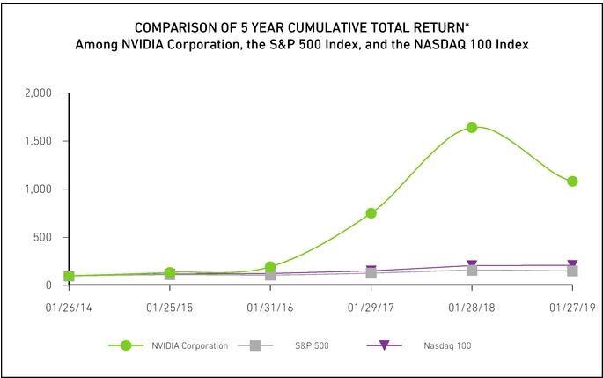

ree cash Flow
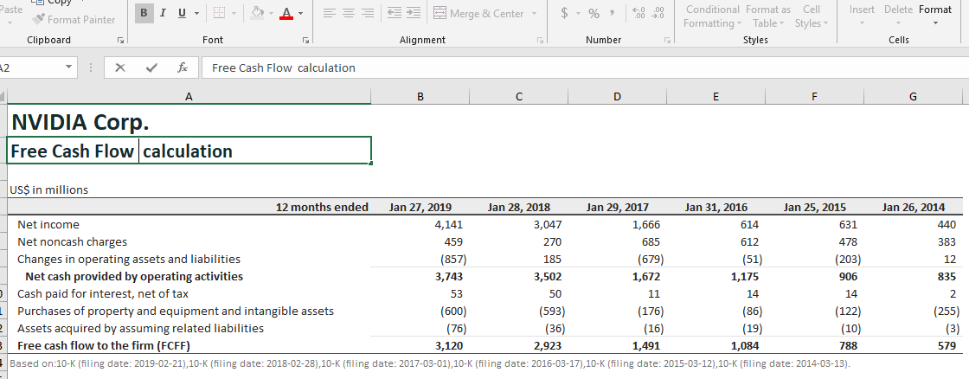
Cost of Capital
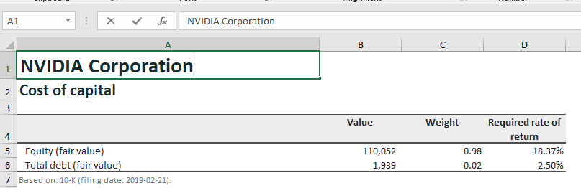
$$Equity (fair value) = No. shares of common stock outstanding × Current share price$$
$$= 609,000,000 × \$180.71 = \$110,052,390,000$$
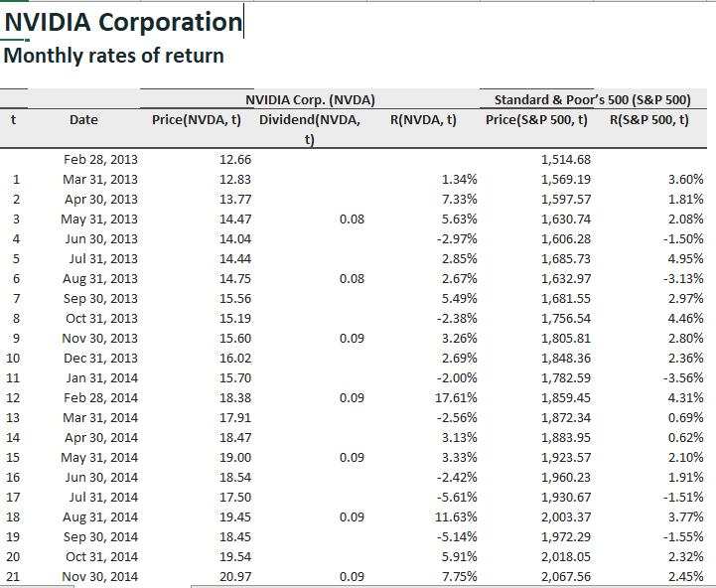
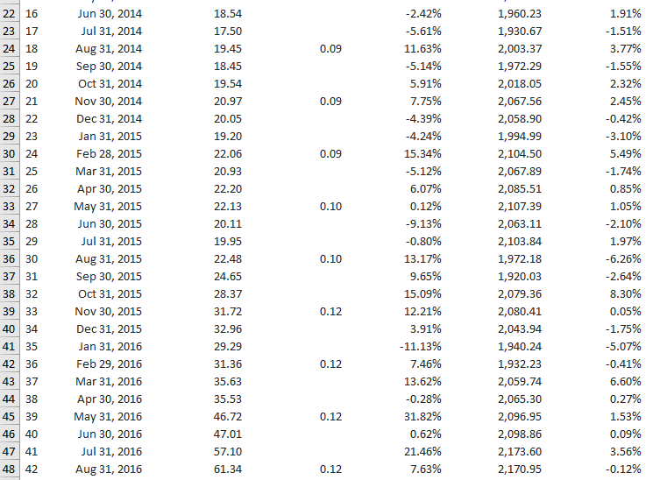

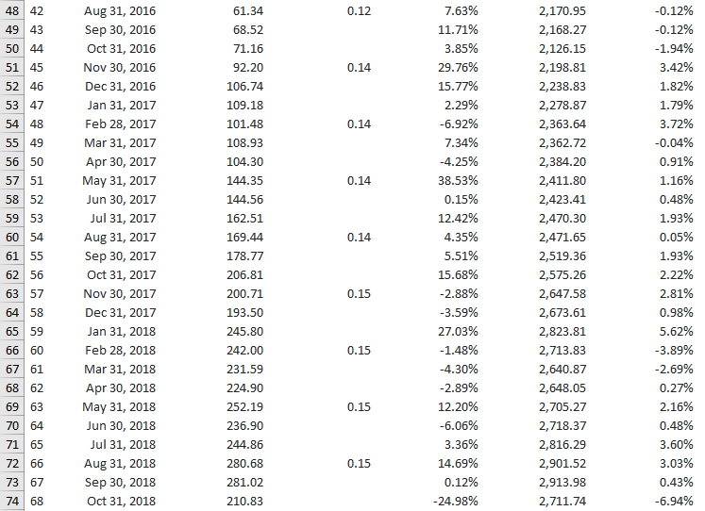
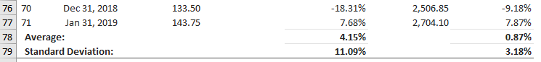

However,$WACC=E/V+Re+ D/V×Rd ×(1-Tc)$
Re, equal to, the total cost of equity
Rd, equal to, the total cost of debt
E, equal to, market value total equity
D, equal to, the market value of total debt
V, equal to, the total market value of the company's combined debt and equity or E + D
E/V, equal to, the equity portion of total financing
D/V, equal to, debt portion of total financing
Tc equal to income tax rate:
As of Jul. 2019 Nvidia, corporation most current two-year average Current Portion of Long
Term Debt was $1986.5 million and its latest two-year average Long-Term Debt & Capital Lease Obligation was $7.5 million. Its total Book value Debt (D) was estimated at
$1994 million(NVIDIA WACC %,n.d.).
Therefore,
- $weight of equity = E/((E + D))= 110052.390/((110052.390 + 1994))= 0.9822$
- $weight of debt = ( D)/((E + D)) = (1994 )/((110052.390\} + 1994)) = 0.0178$
- Cost of Equity =?
$Cost of Equity =$Risk-Free Rate of Return + Beta of Asset × (Expected Return of the Market - Risk-Free Rate of Return)
Expected Return of the Market - Risk-Free Rate of Return = Premium rate = 6% while and the risk-free rate is 1.59%. NVIDIA Beta risk 2.47.
Therefore,$1.59000000\% + 2.47 × 6\% = 16.41\%$
- Cost Debt:
By January, NVIDIA’s interest expense was 58 million with a total Book Value of Debt (D) of $1994 million.
Therefore, $Cost of Debt = 58/1994 = 2.9087\%$
NVIDIA’s latest Two-year Average Tax Rate = -0.815%
Therefore, NVIDIA's Weighted Average Cost of Capital (WACC) as at now is calculated as:
$$WACC=E/((E + D) ) ×Cost of Equity + D/((E + D) ) ×Cost of Equity ×(1 - Tax Rate)$$
= 0.9822 ×16.41% + 0.0178 × 2.9087% × (1 - -0.815%)
= 16.17%
Present value and terminal value of NVIDIA corporation:
According to data from NVIDIA Free Cash Flow 2006-2019: NVDA (n.d.), NVIDIA corporation's free cash flow value for the period ending July 31 was estimated at 1,415.00, a year-over-year. Also, the yearly free cash flow for 2019 was $3.143 billion that marked an increase of 7.97% from 2018. Its annual free cash flow for 2018 was $2.911 billion marking a 93.68% increase from the year 2017. It again steadily realized an increase of 37.14% in 2017 from 2016 with an annual cash flow of $1.503 billion.
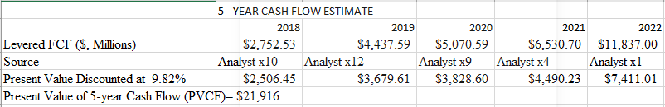
Government bond rate = 2.9% while today’s cost of equity is 9.8%
Therefore, Terminal Value (TV) = FCF₂₀₂₂ × $\frac{(1 + g) }{(r – g) }$ = $11,837× $\frac{(1 + 2.9\%) }{(9.8\% – 2.9\%) }$ = $177,439
And Present Value of Terminal Value (PVTV) = $\frac{TV}{{(1 + r)}^{5}}$ = $\frac{\$177,439}{{1 + 9.8\%}^{5}}$ = $111,093
So, total value of NVIDIA = Total value of present cash flow = $133,009

Part B:

Importance of effective teamwork and coordination of activities in future studies and

professional practice.
Grover, Porter, & Morphet (2017) assert that good collaboration and coordination of tasks is crucial to the accomplishment of the job assigned to the team. This encourages the accomplishment of work at a faster rate as it is achieved by a group of people rather than a single person, generates work cohesion and dedication, enables a healthy spirit of competition between team members and strengthens communication skills such as listening and writing. First of all, I have found that teamwork and organization of tasks have facilitated the accomplishment of work at a faster rate since it is performed by a group of people rather than by a single person. This was possible because questions were given to every member to review and forward the results later (Reeves, Xyrichis,& Zwarenstein,2018). The proposals were then sent to the team leader for approval. Second, I discovered that teamwork was also necessary because it builds unity and dedication to work. Since each team member was given a role to play in our community, they learned that commitment was a vital part of the success of any great team. With this in mind, each participant had to perform the tasks assigned to them within the deadlines set for the benefit of the entire team. In the same way, we learned that the spirit of devotion was an essential aspect that was regarded when an individual was working (Benoliel & Somech,2015).
I also discovered that teamwork encouraged a positive spirit of competition between team members. Through good teamwork and cooperation, our team members have built a strong competitive spirit that has benefited our community. I discovered that it was important to have a strong competitive spirit to help our team accomplish its mission early on. For example, we determined as a group that each individual would have to follow a strict timetable and that the first person to complete the tasks assigned to them would be rewarded(Benoliel & Somech,2015). By doing so, most of the participants completed their tasks earlier than expected, mostly because of the bonus to be offered to the best team member. Besides, I found that successful teamwork and coordination improved communication skills such as speaking, listening and listening and writing. For example, when I needed to get some information from a person, I mastered the art of addressing people with courtesy by using terms such as "with due respect" and "kindly" in the event of seeking help from a member of our team (Grover, Porter, & Morphet, 2017). The use of courteous language in my interactions has charmed me with numerous individuals, most of whom consider me to have a friendly personality and to be ready to provide them with any timely support at any given time. Besides, I have learned that communication skills, such as listening, speaking and reading, are meant to be used appropriately for the successful planning and management of teamwork and professional training tasks. At the appointed time, we had to carry out the plan while listening to each other's input (Reeves, Xyrichis, & Zwarenstein,2018). I've found that to be a good leader, we need to improve top listening skills. It's because the excellent listener is a high-quality thinker, too. When one gives the speaker a chance to hear, the speaker feels privileged and is likely to give the listener the best he can do (Benoliel & Somech,2015). I have heard that an accurate speaker uses the body's facial expressions, emotions, and movements. The use of facial expressions allows the target group an easy time to understand what the speaker says. For example, each representative ensured that specific techniques were used to ensure that all participants in the organizations were sure to understand the values that they shared. In reality, writing is a critical skill that I have learned that is useful for crew work or teamwork. I also discovered that it was important for the preservation of fabric and for the future reference of the society to be noted by the members of the team (Grover, Porter, & Morphet, 2017).

References

Ferguson, E. (2017, April 10). Intel Corporation's SWOT Analysis & Recommendations. Retrieved October 9, 2019, from http://panmore.com/intel-corporation-swot-analysis-recommendations.
Ascimecca. (2018, January 19). Intel. Retrieved October 9, 2019, from https://fortune.com/worlds-most-admired-companies/2018/intel/.
Bhasin, H. (2019, May 15). SWOT Analysis of Intel - Intel Corporation SWOT analysis. Retrieved October 9, 2019, from https://www.marketing91.com/swot-analysis-intel/
Felton, L. (2017). From inside to out: Reinventing a brand globally and locally. Journal of Brand Strategy, 6(2), 120-125.
K., D. (2017, September 15). Intel SWOT Analysis: Heading Into 2017. Retrieved October 9, 2019, from https://medium.com/@danielsfskim/swot-analysis-intel-heading-into-2017-b61e242d41e5.
Intel Net Income 2006-2019: INTC. (n.d.). Retrieved October 9, 2019, from https://www.macrotrends.net/stocks/charts/INTC/intel/net-income.
Neiger, C. (2018, January 19). Better Buy: Intel Corporation vs. NVIDIA. Retrieved October 10, 2019, from https://www.fool.com/investing/2018/01/19/better-buy-intel-corporation-vs-nvidia.aspx.
Msa. (2019, October 2). Intel Mission Statement 2019: Intel Mission & Vision Analysis. Retrieved October 10, 2019, from http://mission-statement.com/in
Self-Driving Cars Technology & Solutions from NVIDIA Automotive. (n.d.). Retrieved October 10, 2019, from https://www.nvidia.com/en-us/self-driving-cars/.
Picardo, E. (2019, June 25). How mergers and acquisitions can affect a company. Retrieved October 10, 2019, from https://www.investopedia.com/articles/investing/102914/how-mergers-and-acquisitions-can-affect-company.asp.
NVIDIA Free Cash Flow 2006-2019: NVDA. (n.d.). Retrieved October 10, 2019, from https://www.macrotrends.net/stocks/charts/NVDA/nvidia/free-cash-flow
NVIDIA WACC %. (n.d.). Retrieved October 10, 2019, from https://www.gurufocus.com/term/wacc/ NVDA/WACC-/NVIDIA-Corp.
Grover, E., Porter, J. E., & Morphet, J. (2017). An exploration of emergency nurses’ perceptions, attitudes and experience of teamwork in the emergency department. Australasian emergency nursing journal, 20(2), 92-97.
Benoliel, P., & Somech, A. (2015). The role of leader boundary activities in enhancing interdisciplinary team effectiveness. Small Group Research, 46(1), 83-124.
Reeves, S., Xyrichis, A., & Zwarenstein, M. (2018). Teamwork, collaboration, coordination, and networking: Why we need to distinguish between different types of interprofessional practice.

